

**Abstract:**

Are you planning to take out a loan or perhaps you already have one, and the term "amortization" keeps popping up in your financial conversations? Don't worry; you're not alone. Amortization can sound like a complex financial term, but in reality, it's a fundamental concept that can have a significant impact on your financial well-being

**What is Amortization?**

Amortization is an accounting technique used to periodically lower the book value of a loan or an intangible asset over a set period of time. Concerning a loan, amortization focuses on spreading out loan payments over time. When applied to an asset, amortization is similar to depreciation.

**Understanding Amortization:**

The term “amortization” refers to two situations. First, amortization is used in the process of paying off debt through regular principal and interest payments over time. An amortization schedule is used to reduce the current balance on a loan — for example, a mortgage or a car loan — through installment payments.

Second, amortization can also refer to the practice of spreading out capital expenses related to intangible assets over a specific duration — usually over the asset’s useful life — for accounting and tax purposes.

An amortization schedule is a table or chart that outlines the periodic payments and allocation of those payments toward the principal and interest on a loan. It provides a detailed breakdown of how a loan is gradually paid off over time. This schedule is particularly common for mortgages, car loans, and other installment loans.

* How long will it take to pay off your loan?
* How much interest will you pay over the life of the loan?
* What happens if you make extra payments?
* What if you want to refinance or pay off the loan early?

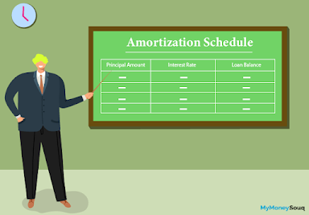

**Types of amortization:**

Amortization can be applied to various financial scenarios, and there are different types of amortization based on the context in which it is used. Here are some common types:

1. **Loan Amortization**

* **Straight-Line Amortization:** Equal principal payments are made over each period, with interest calculated on the remaining balance. This results in gradually decreasing total interest payments over time.
* **Declining Balance Amortization:** The interest is calculated on the outstanding loan balance, leading to varying principal and interest payments. This method often results in higher initial interest payments.

1. **Mortgage Amortization:**

* **Fixed-Rate Mortgage Amortization:** Monthly payments remain constant, but the allocation between principal and interest changes over time, with more going towards principal as the loan matures.
* **Adjustable-Rate Mortgage (ARM) Amortization:** Interest rates may change, affecting the monthly payment amount and the allocation between principal and interest.

1. **Intangible Asset Amortization:**

* **Straight-Line Amortization:** The cost of an intangible asset (e.g., patents, copyrights) is evenly spread over its estimated useful life, resulting in a consistent expense each period.
* **Accelerated Amortization:** Front-loads the amortization expense, recognizing a higher portion of the asset's cost in the earlier periods.

1. **Bond Amortization:**

* **Premium Amortization:** For bonds issued at a premium (higher than face value), the premium is amortized over the bond's life, reducing the premium each period.
* **Discount Amortization:** For bonds issued at a discount (lower than face value), the discount is amortized over the bond's life, increasing the interest expense each period.

1. **Software Amortization:**

* **Straight-Line Amortization:** The cost of software is evenly distributed over its expected useful life, typically in terms of years.

1. **Lease Amortization:**

* **Capital Lease Amortization**: Similar to loan amortization, where periodic payments consist of both principal and interest, reflecting the amortization of the leased asset.
* **Operating Lease Amortization:** Payments are expensed as incurred, and no asset amortization occurs on the lessee's books.

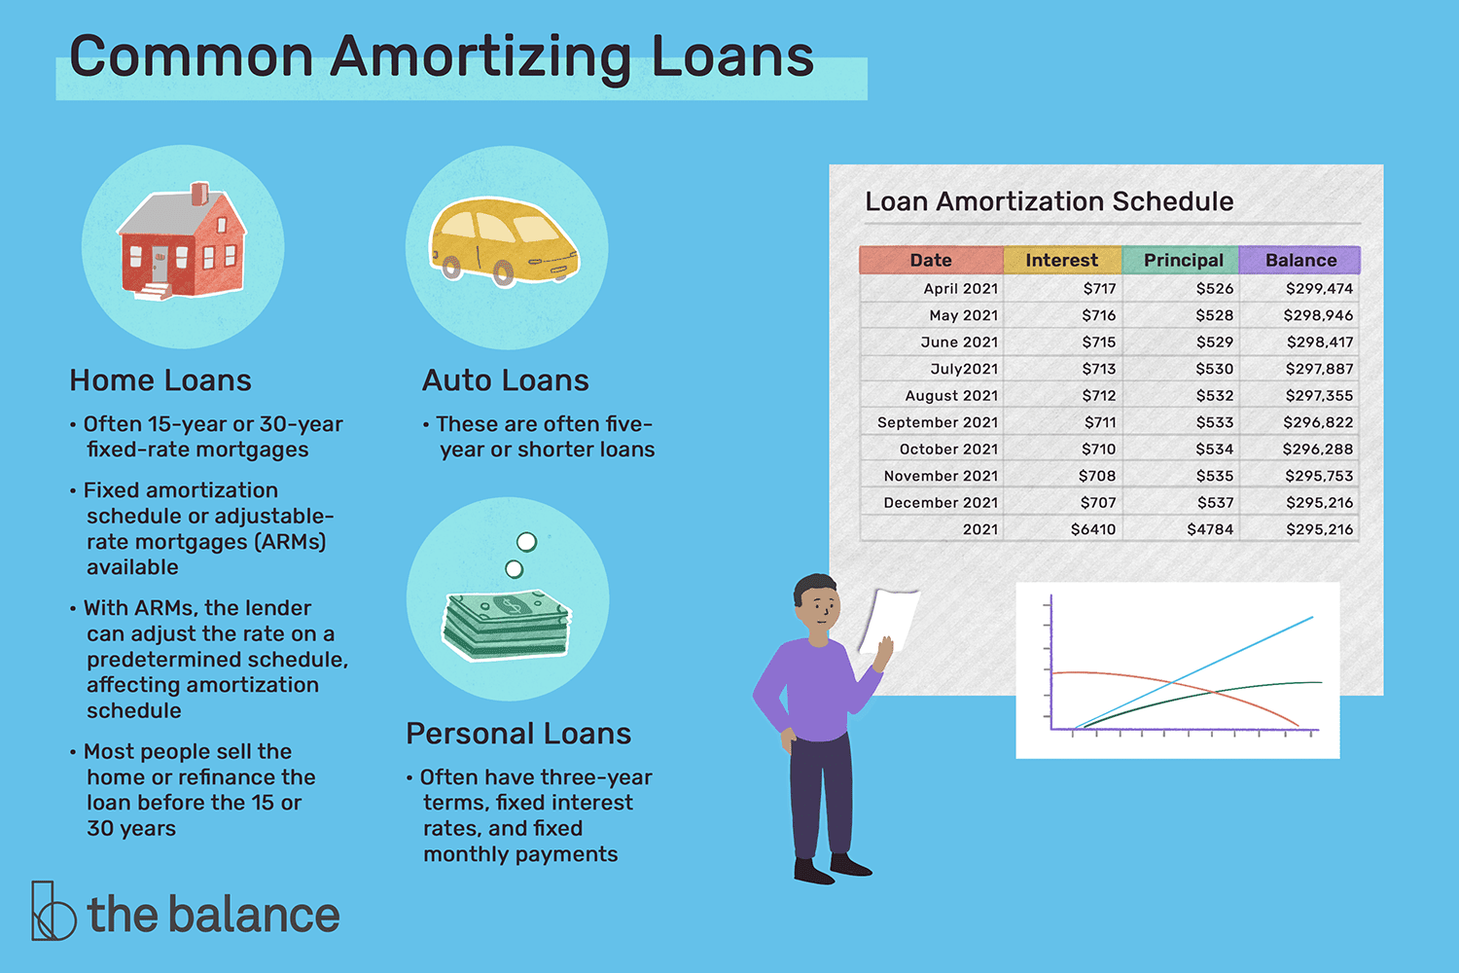**Applications of Loan Amortization:**

**Why Is Amortization Important?**

Amortization is important because it helps businesses and investors understand and forecast their costs over time. In the context of loan repayment, amortization schedules provide clarity concerning the portion of a loan payment that consists of interest versus the portion that is principal. This can be useful for purposes such as deducting interest payments on income tax forms. It is also useful for planning to understand what a company’s future debt balance will be after a series of payments have already been made.

Amortizing intangible assets is important because it can reduce a business’s taxable income, and therefore its tax liability, while giving investors a better understanding of the company’s true earnings. Intangible assets also have a finite useful life; over time, trademarks or patents may lose their value due to obsolescence. Amortizing intangible assets is also a reflection of how a company has “used up” the benefit of these assets.

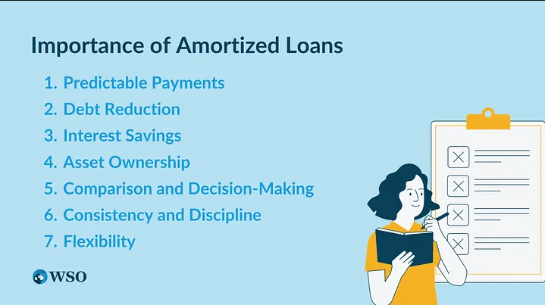

**How we calculate a loan amortization?**

The formula to calculate the monthly principal due on an amortized loan is as follows:​

Where:

* **PMT** is the **monthly payment** (the amount you need to pay each month).
* **P** is the **principal loan amount** (the initial amount borrowed).
* **r** is the **monthly interest rate** (the annual interest rate divided by 12 months).
* **n** is the **total number of payments** (the loan term in months).

To create the amortization schedule, you start with the first payment and then use the following formulas for each subsequent month:

1. **Calculate the interest portion of the payment:**

Interest Payment = P ⋅ r

1. **Calculate the principal portion of the payment:**

Principal Payment = PMT − Interest Payment

1. **Calculate the remaining loan balance after the payment:**

Remaining Balance = P − Principal Payment

Repeat these calculations for each subsequent month, using the new remaining balance as the principal amount for the next month.

Continue this process until you reach the last payment, and the remaining balance becomes zero.

**Preparing amortization schedules:**

Amortization schedules usually have six columns, each communicating information to the borrower and lender. The six columns are often laid out as shown below:



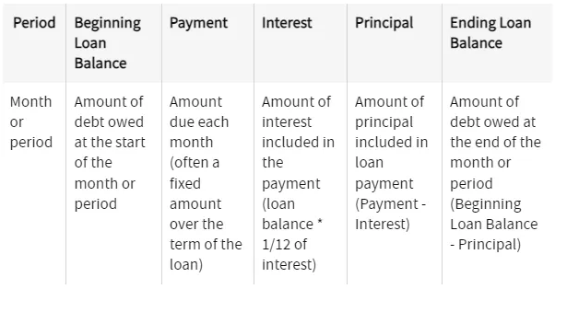

1. **Period:** The period is the timing of each loan payment, often represented on a

monthly basis. However, each row on an amortization represents a payment so if a loan is due bi-weekly or quarterly, the period will be the same. This column helps a borrower and lender understand which payments will be broken down in what ways.

This may either be shown as a payment number (i.e., Payment 1, Payment 2, etc.) or a date (i.e. 1/1/2023, 2/1/2023, etc.).

1. **Beginning Loan Balance:** The beginning loan balance is the amount of debt owed at the beginning of the period. This amount is either the original amount of the loan or the amount carried over from the prior month (last month’s ending loan balance equals this month’s beginning loan balance).
2. **Payment:** The payment is the monthly obligation calculated above. This will often remain constant over the term of the loan. Though you usually calculate the payment amount before calculating interest and principal, payment is equal to the sum of principal and interest.
3. **Interest**: The interest portion is the amount of the payment that gets applied as interest expense. This is often calculated as the outstanding loan balance multiplied by the interest rate attributable to this period’s portion of the rate. For example, if a payment is owed monthly, this interest rate may be calculated as 1/12 of the interest rate multiplied by the beginning balance. Always be mindful of how a lender calculates, applies, and compounds your annual percentage rate as this impacts your schedule. As the outstanding loan balance decreases over time, less interest should be charged each period.
4. **Principal:** The principal portion is simply the left over amount of the payment. This is the total payment amount less the amount of interest expense for this period. As the outstanding loan balance decreases over time, less interest will be charged, so the value of this column should increase over time.
5. **Ending Loan Balance:** The ending loan balance is the remaining principal balance after the principal payment for a given period has been deducted. It represents the outstanding amount of the loan after each payment.

By examining an amortization schedule, borrowers can track their progress in repaying the loan, see how much interest they are paying, and understand how each payment contributes to reducing the outstanding balance. This information can be useful for budgeting and financial planning.

**Example:**

Here’s an amortization schedule for a $50,000 mortages with a 20% interest rate over 15 years.

Firstly, need to calculate the monthly interest rate and the total number of payments.

**Principal Loan Amount (P):** $50,000

**Annual Interest Rate (r):** 20% (0.20 as a decimal)

**Monthly Interest Rate (r/12):** 0.20 / 12 = 0.01667 (rounded to 5 decimal places)

**Total Number of Payments (n):** 15 years * 12 months/year = 180 months

Now, you can calculate the monthly payment (PMT) using the formula:

Calculating this, the monthly payment (PMT) is approximately $952.48.

Now, let’s create an amortization schedule for the first few months:

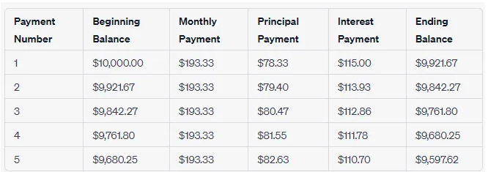

This table represents the first five payments of the amortization schedule. As you can see, with each payment, a larger portion goes toward reducing the principal balance, while the interest portion decreases. The ending balance gradually decreases until it reaches zero at the end of the loan term.

**Conclusion:**

An amortization schedule is a valuable financial tool that systematically breaks down the repayment of loans, mortgages, or the allocation of costs for intangible assets over time. It provides a detailed roadmap of scheduled payments, delineating the distribution between principal and interest components throughout the life of the financial instrument or asset. The schedule not only aids in managing and budgeting for periodic payments but also offers insights into the changing composition of these payments over the course of the amortization period. Through the use of various amortization methods such as straight-line or declining balance, businesses and individuals can tailor their repayment structures to align with financial goals and obligations. Ultimately, amortization schedules contribute to financial transparency, accurate accounting, and informed decision-making, enhancing overall financial management and planning.